 | 13.1.10 Editors - Shader Editor - Header - Add Menu - Color
Table of content
Detailed table of content 1
Add menu - Color 4
Bright/Contrast 4
Outputs 4
Gamma 4
Hue Saturation Value 5
Invert Node 6
Light Falloff 6
Mix Color 7
RGB Curves 9

Detailed table of content
Detailed table of content
Detailed table of content 1
Add menu - Color 4
Bright/Contrast 4
Inputs 4
Color 4
Brightness 4
Contrast 4
Outputs 4
Color 4
Gamma 4
Inputs 4
Color 4
Gamma 5
Outputs 5
Color 5
Hue Saturation Value 5
Inputs / Properties 5
Hue 5
Saturation 5
Value 5
Factor 5
Color 5
Outputs 5
Color 5
Invert Node 6
Inputs 6
Factor 6
Color 6
Outputs 6
Color 6
Light Falloff 6
Inputs 7
Strength 7
Smooth 7
Outputs 7
Quadratic 7
Linear 7
Constant 7
Mix Color 7
Data Type 7
Color 7
Inputs 7
Factor 7
Color 1 8
Color 2 8
Properties 8
Mix 8
Clamp Result 8
Clamp Factor 8
Outputs 8
Result 8
Vector 8
Inputs 8
Factor 8
A 8
B 8
Properties 8
Factor Mode 8
Clamp Factor 8
Outputs 8
Result 8
Float 9
Inputs 9
Factor 9
A 9
B 9
Properties 9
Clamp Factor 9
Outputs 9
Result 9
RGB Curves 9
Inputs 9
Factor 9
Color 9
Properties 9
Curve Field 9
Channel buttons 9
Navigation elements 10
Zoom in and out 10
Use Clipping 10
Tools 10
Reset View 10
Extend horizontal 10
Extend extrapolated 10
Reset Curve 10
Curve edit field 10
Selecting Points 10
Adding Points 10
Curve point settings 11
Vector Handle 11
Auto Handle 11
Auto Clamped Handle 11
Outputs 11
Color 11

Add menu - Color

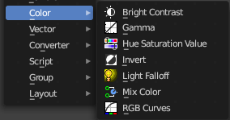
This sub menu contains color related nodes.

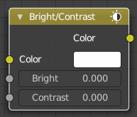
Bright/Contrast

Inputs

Color
Standard input.

Brightness
An additive-type factor by which to increase the overall brightness of the image. Use a negative number to darken an image.

Contrast
A scaling type factor by which to make brighter pixels brighter, but keeping the darker pixels dark. Higher values make details stand out. Use a negative number to decrease the overall contrast in the image.

Outputs

Color
Standard output.
Note. It is possible that this node will put out a value set that has values beyond the normal range, i.e. values greater than one and less than zero. If you will be using the output to mix with other images in the normal range, you should clamp the values using the Map Value node (with the Min and Max enabled), or put through a Color Ramp node (with all normal defaults).

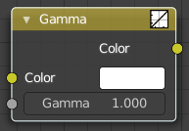
Gamma
Use this node to apply a gamma correction.

Inputs

Color
Standard image input.

Gamma
An exponential brightness factor.

Outputs

Color
Standard output.

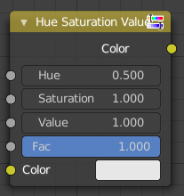
Hue Saturation Value
The Hue Saturation Node applies a color transformation in the HSV color space. Called “Hue Saturation Value” in shader and texture context.

Inputs / Properties
The inputs also works as properties when nothing is connected.

Hue
Specifies the hue rotation of the image. 360° are mapped to (0 to 1). The hue shifts of 0 (-180°) and 1 (+180°) have the same result.

Saturation
A saturation of 0 removes hues from the image, resulting in a greyscale image. A shift greater than 1.0 increases saturation.

Value
Value is the overall brightness of the image. De/Increasing values shift an image darker/lighter.

Factor
Controls the amount of influence the node exerts on the output image.

Color
Standard input.

Outputs

Color
Standard output.
Hue/Saturation Tips
Some things to keep in mind that might help you use this node better:
Hues are vice versa
A blue image, with a Hue setting at either end of the spectrum (0 or 1), is output as yellow (recall that white, minus blue, equals yellow). A yellow image, with a Hue setting at 0 or 1, is blue.

Hue and Saturation work together.
So, a Hue of 0.5 keeps the blues the same shade of blue, but Saturation can deepen or lighten the intensity of that color.
Gray & White are neutral hues
A gray image, where the RGB values are equal, has no hue. Therefore, this node can only affect it with Value. This applies to all shades of gray, from black to white; wherever the values are equal.
Changing the effect over time
The Hue and Saturation values can be animated with a Time Node or by animating the property.

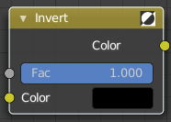
Invert Node
The Invert Node inverts the colors in the input image, producing a negative.

Inputs

Factor
Controls the amount of influence the node exerts on the output image.

Color
Standard input.

Outputs

Color
Standard image output.

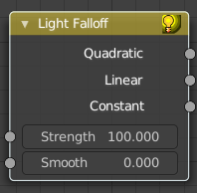
Light Falloff
Cycles Only
The Light Falloff node allows you to manipulate how light intensity decreases over distance. In reality light will always fall off quadratically; however, it can be useful to manipulate as a non-physically-based lighting trick. Note that using Linear or Constant falloff may cause more light to be introduced with every global illumination bounce, making the resulting image extremely bright if many bounces are used.

Inputs

Strength
Light strength before applying falloff modification.

Smooth
Smooth intensity of light near light sources. This can avoid harsh highlights, and reduce global illumination noise. 0.0 corresponds to no smoothing; higher values smooth more. The maximum light strength will be strength/smooth.

Outputs

Quadratic
Quadratic light falloff; this will leave strength unmodified if smooth is 0.0 and corresponds to reality.

Linear
Linear light falloff, giving a slower decrease in intensity over distance.

Constant
Constant light falloff, where the distance to the light has no influence on its intensity.

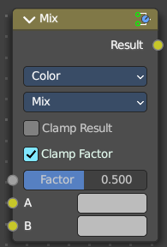
Mix Color
The mix Color node is in real the Mix node in Color mode. It is shared across editors.
The Mix node is meant to mix values. This can be colors, or also a vector or a single value.
Note that the Mix Color node does not start in Color mode when you insert it from the sidebar due a techical limitation in the Blender Python api. Here you have to manually switch to the color mode.

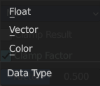
Data Type
The mode in which the node works.

Color
The Mix Node in color mode mixes images by working on the individual and corresponding pixels of the two input images. Called “MixRGB” in the shader and texture context.

Inputs

Factor
Controls the amount of influence the node exerts on the output image.

Color 1
Usually the background image. The image size and resolution sets the dimensions of the output image.

Color 2
Usually he foreground image.

Properties

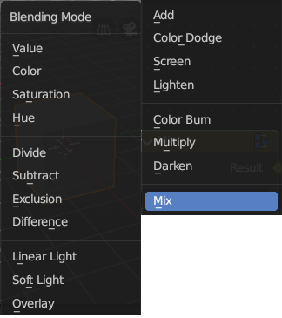
Mix
Choose the different blending modes.
Add, Subtract, Multiply, Screen, Divide, Difference, Darken, Lighten, Overlay, Color Dodge, Color Burn, Hue, Saturation, Value, Color, Soft Light, Linear Light.

Clamp Result
Clamp the result to 0, 1 range.

Clamp Factor
Clamp the factor to 0, 1 range.

Outputs

Result
Standard output.

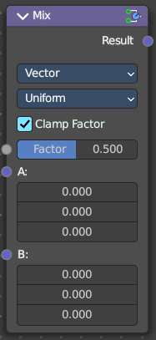
Vector
The vector mode allows you to mix vectors.

Inputs

Factor
Controls the amount of influence.

A
The input vector.

B
The output vector.

Properties

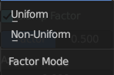
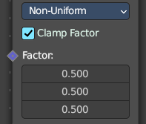
Factor Mode
Use a single factor for all values, or a factor per value.

Clamp Factor
Clamp the factor to 0, 1 range.

Outputs

Result
Standard output.

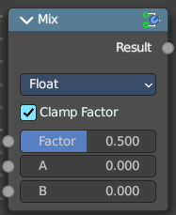
Float
The vector mode allows you to mix vectors.

Inputs

Factor
Controls the amount of influence.

A
The input value.

B
The output value.

Properties

Clamp Factor
Clamp the factor to 0, 1 range.

Outputs

Result
Standard output.

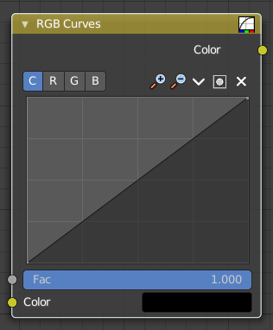
RGB Curves
The RGB Curves Node allows color corrections for each color channel and levels adjustments in the compositing context.

Inputs

Factor
Controls the amount of influence the node exerts on the output image.

Color
Standard image input.

Properties

Curve Field

Channel buttons
Clicking on one of the channels displays the curve for each.
C (Combined RGB), R (Red), G (Green), B (Blue).

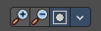
Navigation elements
They are described from left to right.

Zoom in and out
The two buttons with the magnifying glass at it zooms in and out in the curve window.


Use Clipping
Clipping options. Set up clipping for the stroke.

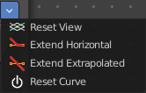
Tools
Tools is a menu where you can find some curve related tools.

Reset View
Resets the curve windows zoom.

Extend horizontal
Extends the curve before the first curve point and behind the last curve point horizontally.

Extend extrapolated
Extends the curve before the first curve point and behind the last curve point extrapolated.

Reset Curve
Resets the curve to the initial shape.

Curve edit field
Create and tweak a Bezier curve that varies the input levels (X axis) to produce an output level (Y axis).

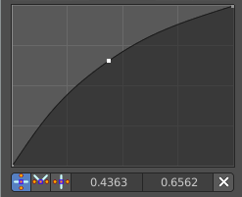
Selecting Points
You can select curve points. This reveals two edit boxes for the x and y coordinate of this point.
Selected points can be moved around. Left click at them, hold the mouse button down and move them to a new location.

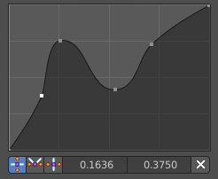
Adding Points
You can add new curve points by simply left clicking at the curve. Move the mouse to position them where you need it.

Curve point settings
When you have a point selected then you will reveal further settings at the bottom.

Vector Handle
Set handle type to Vector.

Auto Handle
Set handle type to Auto.

Auto Clamped Handle
Set handle type to Auto Clamped.

Outputs

Color
Standard output.

